Reflection Journal Report for Lab 04
Prepared for Prof. Vishwantha Rao, HCC ITAI 1371 Machine Learning
Prepared by FA26_ML_6171_16347 3_ITAI1371 Group
01-Sep-2026

The purpose of this report is for each student to reflect on their learning journey for ITAI 1371 Machine Learning (ML) Lab 04. This Reflection Journal Report consists of separate parts for each student in the group. Each student in the group was responsible for their own content and report formatting in each of the sections below.

This reflection journal entry is for Lab 04 Google Collab Gradients and was prepared by Irene “Alex” Ramos.

Academic Reflective Journal for Irene Ramos Lab 4

- Introduction:
The objective of the following reflection journal report is to analyze the process of learning experience in the context of ITAI 1371 Machine Learning (ML) Lab 04 that is concentrated on Exploratory Data Analysis (EDA). This lab was completed by Irene “Alex” Ramos and provides an insight into the practical application of the process of discovering data properties, dealing with missing data, and visualizing relations prior to developing predictive models. The main objective of the reflection paper is to evaluate the process of data transformation from its initial stage to structural understanding.
- Description of Experience or Topic:
The lab exercise enabled me to gain practical experience of exploratory data analysis by working with the popular Titanic passenger dataset. The process consisted of clearly defined steps:

Data Preparation and Load: Loaded the dataset directly from a web location using Pandas, viewing the first few records as well as using .info() function to check the number of non-null values and datatypes for all twelve variables.
Basic Statistics: Computed basic statistics for numerical features using .describe() function and computed the essential statistics including minimum, maximum, mean, and standard deviation.
Visual Exploratory Data Analysis: Constructed statistical plots using Seaborn library to create visual representations out of numeric statistics being: Survival Distribution: Constructed count plots to see the distribution of the target, Passenger Class & Gender: Constructed categorical split plots with hue argument to visualize how passenger's chances of survival differ depending on social standing and the common notion of "women and children first." And Age Distributions: Constructed facetted histograms to see the anomalies in age distributions and survival rate spikes.
Student Explorations: Performed independent analysis to see how port of departure (Cherbourg, Queenstown, Southampton) and ticket prices affect survival rate.
- Personal Reflection:
From this lab, I could conclude that figures and summary statistics tell us only a part of the truth. In particular, the figures of descriptive statistics provide a general perspective on the age distribution and fare prices, but it becomes possible to discover the important patterns once the visualization methods like the count plots and box plot graphs are introduced.
From the very beginning, it was possible to conclude from the visualization of data that this dataset has an extremely uneven balance in the number of deaths and survivors. Checking of passenger class and gender confirmed that socio-economic advantage and demographics were the important factors influencing survival chances. It became obvious that the exploratory data analysis is an indispensable detective phase which can prevent the structural biasness and missing value issues in columns such as Cabin and Age.
- Discussion of Improvements and Learning:
This lab has helped to shape my perceptions and knowledge related to data preprocessing and feature evaluation in a dynamic and practical manner. Some of the important learnings include:
Proficiency in Visual Tools: I became more proficient in using Seaborn for creating count plots, histograms, and box plots. This gave me a better understanding of how to interpret relations between various features.
Imbalance in Real-Life Data: It made me understand that imbalanced data is a common reality, which requires one to be careful while interpreting the evaluation metrics so that there won’t be any favoritism towards the majority class.
Practical Applications: Apart from learning in classroom conditions, these EDA concepts have applications in the industry, such as the analysis of historical metrics and performance of the systems.
- Conclusion:
In summary, through Lab 04, it is clear that EDA plays an important role in being the backbone of machine learning. It provided a way to explore raw data by using descriptive statistics and visualizations in order to identify outliers and understand the relationships. The knowledge gained from learning the concepts is key in building better machine learning models in the future.

This reflection journal entry is for Lab 04 Google Collab and was prepared by Eric Roberson.
- Understanding Insights & New Breakthroughs
“It’s all about the setup, Baby!’ My personal quote that I’ve coined as part of this exercise. From our readings, I discovered that exploratory data analysis (EDA) is a critical function in the machine learning process. According to an article written by Shittu Olumide, “EDA is the process of investigating a dataset to summarize its key characteristics, such as mean, median, and data types. It helps identify errors like missing values, outliers, and duplicates. Additionally, EDA uncovers relationships between variables and guides your next steps, such as feature engineering or model selection.”

- Analyzing the Problem / Problem Solving Strategies
The strategy on how to do EDA is quite clear. While an iterative process which is performed throughout any project, it absolutely must be performed at the very beginning. EDA is the foundation on which everything else relies. According to Olumide’s article, here’s the process using Python:
- Load & inspect the data
- Determine the dataset structure including
  - Dataset Structure
  - Data Quality Flags (invalid and/or missing data)
  - Data Type Issues
- Clean the data (which includes filling in the missing data)
- Visualize distributions and relationships
Olumide goes on to provide a list of common pitfalls and how to avoid them, which includes the following:
- Overlooking Outliers: Use boxplots to spot them
- Misinterpreting Correlation: Correlation ≠ causation; dig deeper
- Ignoring Categorical Variables: Use value_counts() or bar charts
When parsing the IPYNB file, data revealed some strong predictors about the Titanic dataset relative to survival. Passenger class mattered significantly as first-class passengers survived at a much higher rate than passengers in third-class. This likely reflected better access to lifeboats. Gender was the strongest pattern in the data: a much higher proportion of females survived compared to males, consistent with the "women and children first" evacuation approach. Age also played a role, with younger passengers showing somewhat better survival odds than adults, though this effect was weaker than class or gender. Overall, the data suggests that being female and in a higher class were the two biggest advantages for survival, with fare, class, and to some extent age all reinforcing the same underlying story of who had greater access to safety. We’ve all seen the movie the Titanic, and if you’re old enough, watched documentaries in High School history classes about the Titanic. Knowing the history beforehand made it easier for me to glean this information from the data.

- Real-World Applications
This lab got me thinking about visualizing data in tables and charts in Excel. My inkling is that anything there’s a table or Excel file involved, there is an opportunity to visualize the data using Python. While this is not exactly EDA, my mind is beginning to shift about the way I consume data at work and opportunities to do it differently.

I used the violin to analyze embarkation and survival rate as depicted in the graph below.

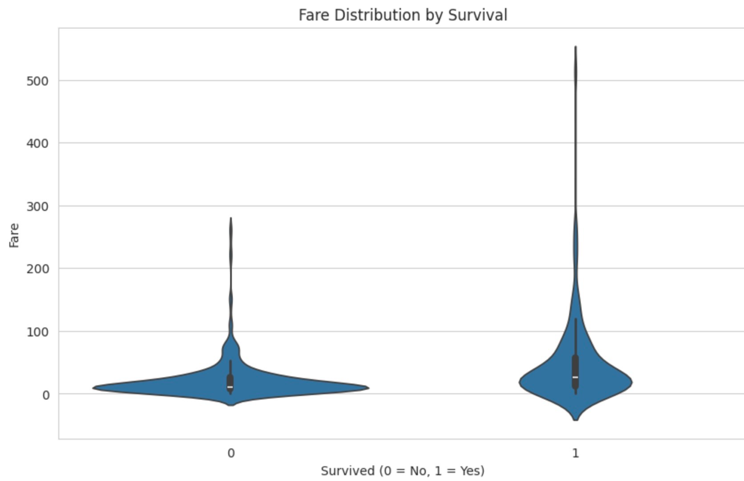

- S (Southampton) was by far the most common port — most passengers boarded there, and it shows the highest raw counts for dead or alive.
- C (Cherbourg) passengers showed a noticeably better survival rate proportionally (more orange relative to blue than the other two ports).
- Q (Queenstown) sat in between, though was a much smaller sample size, so patterns there were less reliable.
The reason Cherbourg looks better isn't really about the port itself. Cherbourg had the higher set proportion of first-class passengers, and I found that first-class had a much higher survival rate. So Embarked is likely acting as a proxy for social class rather than being a real causal factor on its own. EDA helped spot this confounding variable.

- Connecting New & Prior Knowledge
In a former role as VP in Problem Management, I performed root cause analysis (RCA) on Sev 1 incidents. Of course, RCAs are usually performed post-Mortem after incidents occurred, although sometimes they are proactive based on thematic trends observed across the IT service management (ITSM) functions. For example, changes failing repeatedly.

What I have connected is that EDA is very similar to the RCA process, except it is pre-machine learning. We use EDA mostly at the beginning of the project rather than at the end; however, EDA is an iterative process which can be re-started again at any point in time during a project.

Considering how much I loved working in problem management, I feel that I would be very good at EDA and it would be an area of ML in which I would enjoy working. This functional area genuinely piques my interest.

- Emerging Questions
I have the following emerging questions after completing this lab:
- Do I need to be an expert in statistical analysis to be good at EDA? (The last time I worked with statistics was when I took Research Methods in the Social Sciences at UHD for my ungraded degree back in 2010 – this lab is very reminiscent of the work I did with MatLab.)
- Is the Python coding / approach always the same? What are the nuances based on data types? (My belief is that it’s the same approach with the same coding each time.)
- Is EDA a dynamic or static approach? (Can I develop a checklist to reuse each and every time?)
- How long should you spend on EDA at the beginning of a project? (Obviously, time would correlate with size/amount of data but there has to be a way to estimate the time spend.)
- Or, do you spend about the same amount of time on EDA at the beginning if it is a more static approach regardless of the amount of data at hand?

- Changing Approach & Critical Thinking
Lab 04 asked us to respond to the following questions in a markdown cell.

1. What is the primary goal of Exploratory Data Analysis (EDA)?
The primary goal of EDA is to understand a dataset's main characteristics before building a model — its patterns, relationships between variables, anomalies, and quality issues (like missing or incorrect values). It helps form hypotheses about what might predict your target variable and catches problems early, so you build an understandable model and understand the context around the data.

2. Based on the plots in this lab, what kind of person had the best chance of surviving the Titanic?
Based on the visualizations, the passengers with the best chance of survival were first-class (rich) females who boarded from Cherbourg. The Pclass plot showed first-class passengers survived at a much higher rate than third-class, and the sex plot showed a large gap favoring females over males. The fare plot reinforced this, since higher fares which were correlated with first-class lined up with higher survival. For age, younger passengers had somewhat better odds surviving than adults, although the effect was less dramatic than class or gender. So overall: a young, wealthy woman in first class had the best odds of surviving.

3. Why is it important to visualize data instead of just looking at summary statistics?
Summary statistics like the mean or count can hide important structure in the data. For example, two very different distributions can have the same mean — one might be a single cluster around that value, while another could be bimodal (two separate groups) or heavily skewed by outliers. A plot lets you see the shape of the data: how it is spread out, whether there are clusters, outliers, or unusual gaps, and how it compares across categories. In this lab specifically, the boxplot of Fare vs. Survived showed the spread and outliers in ticket prices in a way a single average fare number could not, and the countplots made relationships between categorical variables (like Pclass and Survived) visible in a way a plain table does not.

This reflection journal entry is for Lab 04 Google Collab Gradients and was prepared by Yuanyuan Kou
This lab helped me understand the purpose and importance of Exploratory Data Analysis, also called EDA. Before completing this lab, I knew that data needed to be reviewed before it could be used, but I did not fully understand how much information we could learn from simple statistics and visualizations. Through the Titanic dataset, I learned how to examine data step by step and turn numbers into meaningful information.
The first step was loading the Titanic dataset with Pandas and viewing its first five rows. This gave me a basic understanding of the dataset and its columns. The dataset included information such as passenger class, gender, age, fare, port of embarkation, and survival status. Using df.info() helped me see the data types and the number of non-null values in each column. I noticed that the Age and Cabin columns contained missing values. This was important because missing information may affect later analysis and machine learning results. I learned that checking data quality should be one of the first steps in any data project.
Next, I used df.describe() to examine the numerical columns. It showed statistics such as the mean, standard deviation, minimum, and maximum. For example, I learned that the average passenger age was about 30 years and that the overall survival rate was about 38 percent. I also noticed that ticket fares had a very wide range. Some passengers paid very little, while a small number paid extremely high fares. These statistics gave me a general picture of the dataset, but they did not show the complete story.
The visualization section was the most interesting part of the lab for me. The first count plot showed that more passengers died than survived. This helped me understand the idea of an imbalanced dataset. If one result appears much more often than another result, a machine learning model may have difficulty learning both groups equally well. Before this lab, I thought accuracy alone could always show whether a model was good. Now I understand that the balance of the target groups should also be considered.
The survival plots showed clear differences among passengers. Female passengers had a much higher survival rate than male passengers. First-class passengers also had a better chance of survival than third-class passengers. The age histograms showed that young children had a noticeable survival advantage. These patterns supported the historical idea of “women and children first.” The graphs made these differences much easier to see than summary statistics alone.
For the student experimentation section, I explored survival by port of embarkation. Most passengers boarded at Southampton, but passengers who boarded at Cherbourg appeared to have a higher survival rate. At first, I thought the embarkation port itself might have affected survival. After thinking more carefully, I realized that another variable could explain this pattern. For example, more first-class passengers may have boarded at Cherbourg. This helped me understand an important lesson: a relationship between two variables does not always mean that one directly caused the other.
I also created a box plot to compare fares for passengers who survived and passengers who did not survive. The plot showed that survivors generally paid higher fares. It also showed several unusually high fares. At first, I wondered whether these values were mistakes. I then learned that they were outliers and could represent passengers who paid very high prices for their tickets. Outliers should be examined carefully because they may be real values, data-entry errors, or special cases. They should not be removed without a good reason.
One challenge for me was understanding where to enter different types of answers in the notebook. English is not my first language, so I needed to read the instructions carefully. I learned that code cells are used to enter and run Python code, while Markdown cells are used for written explanations, analysis, and reflection answers. Understanding this difference made it easier for me to organize my work and complete the Knowledge Check correctly.
This lab also improved my understanding of Pandas, Matplotlib, and Seaborn. Pandas helped me load and examine the data. Matplotlib helped control the figure size, titles, labels, and display of the plots. Seaborn made it easier to create statistical graphs such as count plots and box plots. I am becoming more comfortable reading Python code and understanding how each line affects the final result.
If I continued this analysis, I would explore more relationships among the variables. For example, I would compare passenger class with embarkation port to better understand why passengers from Cherbourg had a higher survival rate. I would also examine family size by combining the SibSp and Parch columns. This might show whether traveling alone or traveling with family affected a passenger’s chance of survival. I would also think carefully about how to handle the missing Age and Cabin values before building a machine learning model.
Overall, this lab showed me that EDA is an essential part of the machine learning workflow. It helps us understand the structure and quality of data, discover important patterns, identify possible problems, and decide what to examine next. My biggest lesson was that we should not accept a pattern without thinking about possible explanations behind it. Data can show a relationship, but careful analysis is needed to understand what that relationship means. After completing this lab, I feel more confident using statistical summaries and visualizations to explore a real dataset.

This reflection journal entry is for Lab 04 Google Collab Gradients and was prepared by Xiomara Torres:
The purpose of this lab is to introduce Exploratory Data Analysis and demonstrate how it is used to understand a dataset before creating a machine learning model. During this lab, I worked with the Titanic dataset and used different libraries for Pandas, Matplotlib, and Seaborn to examine the information and reveal patterns. This lab helped me understand how data can be very important in making new discoveries when it is properly inspected and shown.
The lab started by loading the Titanic dataset and reviewing the first few rows. I noticed the functions df.info () and df.describe() were used to help extract the core components of the data. This included information about each passenger, their gender, class, ticket fare, port of embarkation, and whether they survived.
Once I started reviewing the data, I created visualizations. The graphs showed who had the highest chances of survival, the female passenger's and first-class passengers were first. Younger passengers followed closely behind as well. This lab demonstrated how visual representations can make relationships within data much easier to recognize.
Before completing this lab, I understood that data needed to be reviewed before being used. The visualizations showed patterns that could not have been easily identified by the numbers alone. The most interesting part to me was seeing how clearly gender and passenger classes affected survival chances. Wealthier passengers had better access to lifeboats, while women and children were given priority as well. This data is not just a collection of numbers, but it also tells a story.
This lab helped me become more comfortable using Pandas, Matplotlib, and Seaborn. I learned that pandas can be used to inspect and summarize data, and Matplotlib and seaborn can turn that data into graphs. One concept I would like to improve upon is learning to recognize which graph is the most appropriate for which kind of data. Continuing to practice with different datasets will help me better understand the entire EDA process instead of only following the provided steps.
Over this Lab 04 helped me understand why exploratory data analysis an important part of the machine learning process is. EDA allows us to examine the quality and structure of data and discover unseen patterns. My biggest takeaway from this lab is how visual representation of data provides another point of view and allows a different look into data that numbers alone cannot provide.

